XUM ENTERPRISE

User Manual

**www.drmem.com**

**support@drmem.com**

**+44 161 877 0030**

PAGE 1

**1.**

**BEFORE YOU START**

* + 1. Location For Your New PC

CONTENTS

**6.**

**MOTHERBOARD & REMOTE**

6.1 Motherboard Specifications

6.2 Remote Control

PAGE 10

PAGE 9

**5.**

**HEADPHONES & SPEAKERS**

5.1 Headphones & Speakers

**NETWORK, MOUSE & KEYBOARD**

4.1 Network

4.2 Mouse & Keyboard

4.3 Useful Key Bindings

**4.**

PAGE 6

PAGE 12

**8.**

PAGE 11

**7.**

**HOW TO RETURN A PC**

8.1 Contact us

8.2 Returns Checklist

8.3 Warranty

**BIOS BEEP GUIDE**

7.1 BIOS Beep Guide

PAGE 3

**3.**

**CONNECTING A MONITOR**

3.1 Single Monitor

3.2 Dual Monitors

**POWERING YOUR COMPUTER**

2.1 Powering Your Computer

PAGE 2

**2.**

BEFORE YOU START

* 1. **Location For Your New PC**

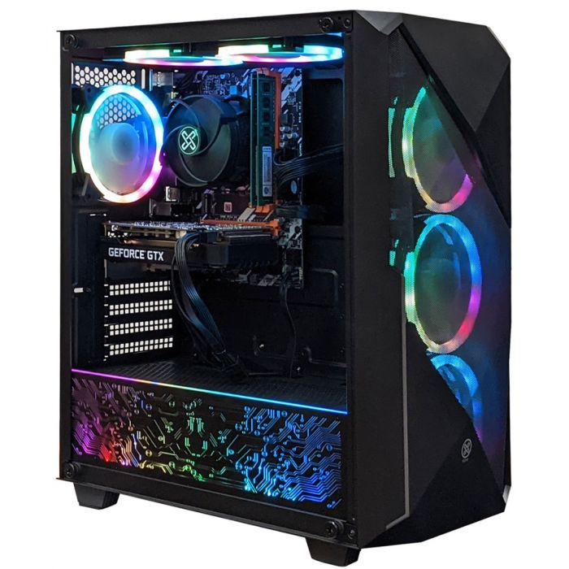



1. Decide where you are going to locate the **PC**, as gaming **PCs** require **adequate ventilation**.
2. Place the **PC** in an area with plenty of **unobstructed space** so the fans can circulate air freely.
3. Be careful to leave at least **30 cm** at the rear & top of the PC so heat can be **properly dissipated.**
4. Be careful not to **block**, or **cover**, any of the fans at the front of the PC as these **vents** provide cool air flow.
5. Make sure not to sit the **PC** near **radiators**, **hot pipes**, or any other **heat sources**.

PAGE 1

POWERING YOUR COMPUTER

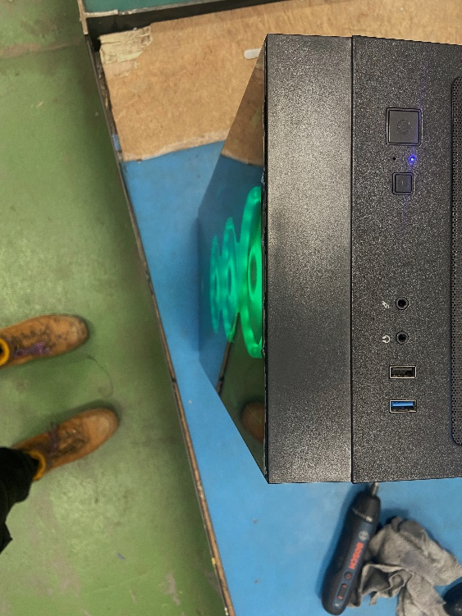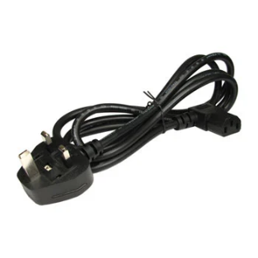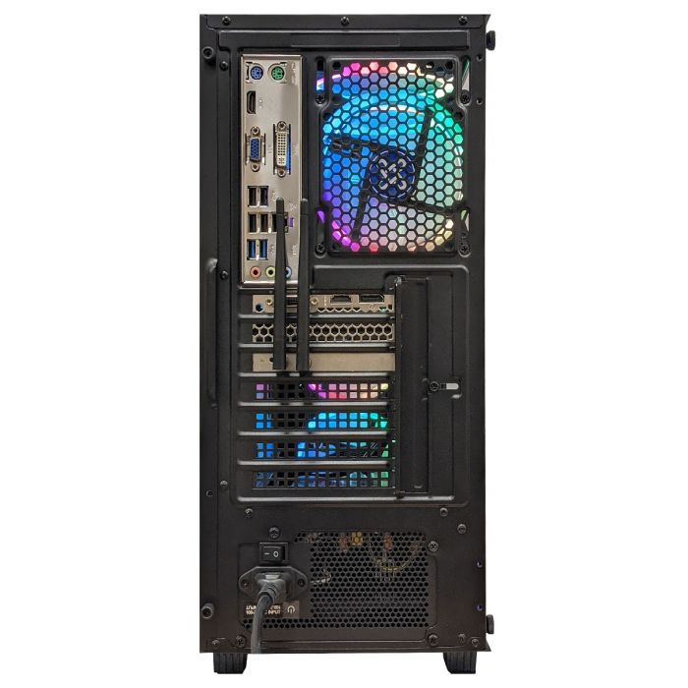

* 1. **Powering Your Computer**

PAGE 2

ON | OFF

1. Plug the **power cable** in at the rear of the PC (Make sure the **I/O** switch is **OFF**).
2. Turn on power to the **PC** using the switch on the rear.
3. Press the **power button** on the top of the PC.

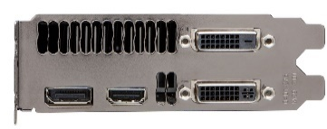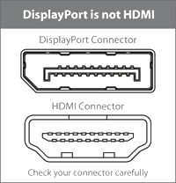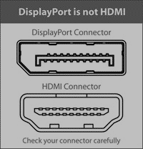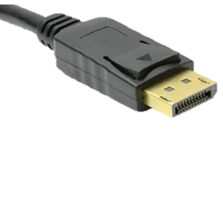

* **Dedicated Graphics Card** **(DGC)** Ports (**Use these if present**).

DVI – D | I

CONNECTING YOUR MONITOR

* This is the side of the **Graphics Card.**
* This is the side of the **Motherboard**; **Integrated Graphics Ports (IGP)** are found here.
* Integrated Graphics Ports **WILL NOT** give a display if there is a **DGC** Installed **(Below).**
* Gaming PCs with **Dedicated Graphics Cards** **(DGC)**.

PAGE 3

Display Cables (**KEY**)

HDMI

VGA

Display Port

* 1. **Single Monitor**

CONNECTING YOUR MONITOR

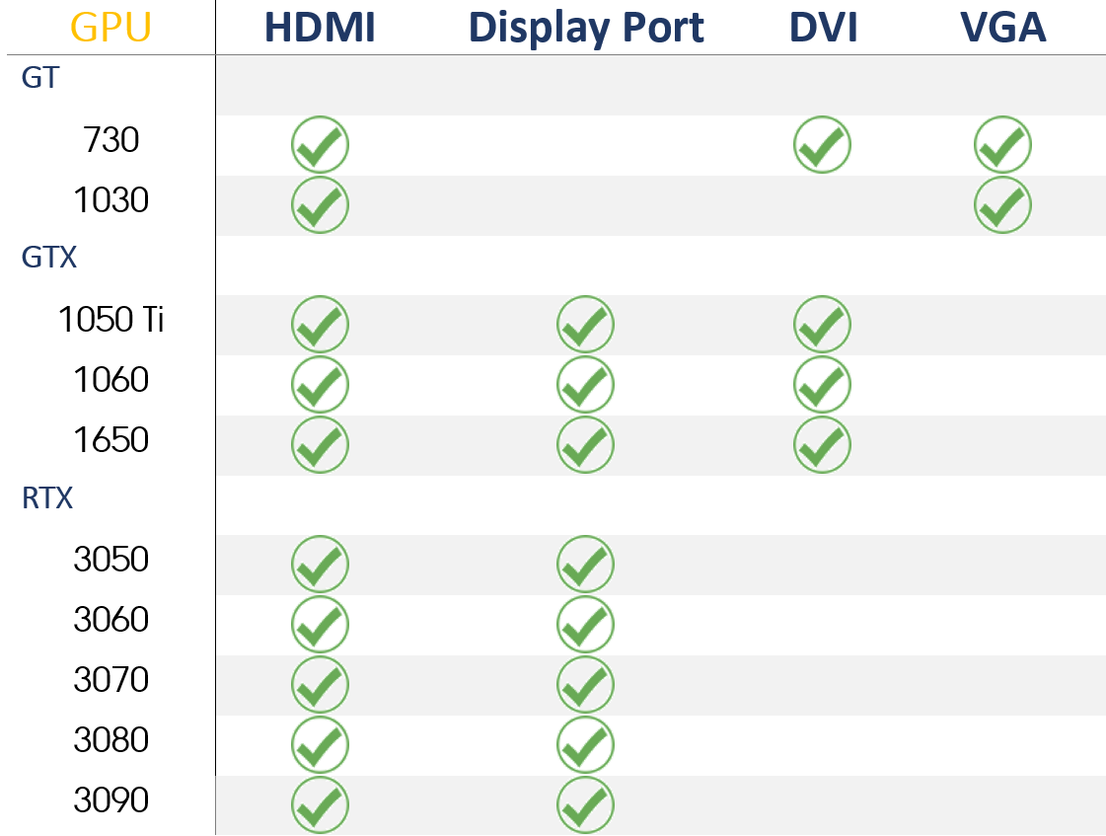

* 1. **Dual Monitors**
* You may want to **maximize** the screen size by having **twin monitors**.
* This is very easy to do with **XUM** **Gaming PCs**. You will need the following cables to connect the **GPU** to the monitors.
* See the table below to check what cables you need depending on the **graphics card**.
* You should connect both the **primary display** and **secondary display** into the graphics card if you are gaming on **both monitors**, if both monitors are running **different programs**, you should connect the **secondary display** into the **IGP** on the **motherboard**.
* You may need a second **adapter or cable** if you wish to convert a connection, **DVI to HDMI** for example.

PAGE 4

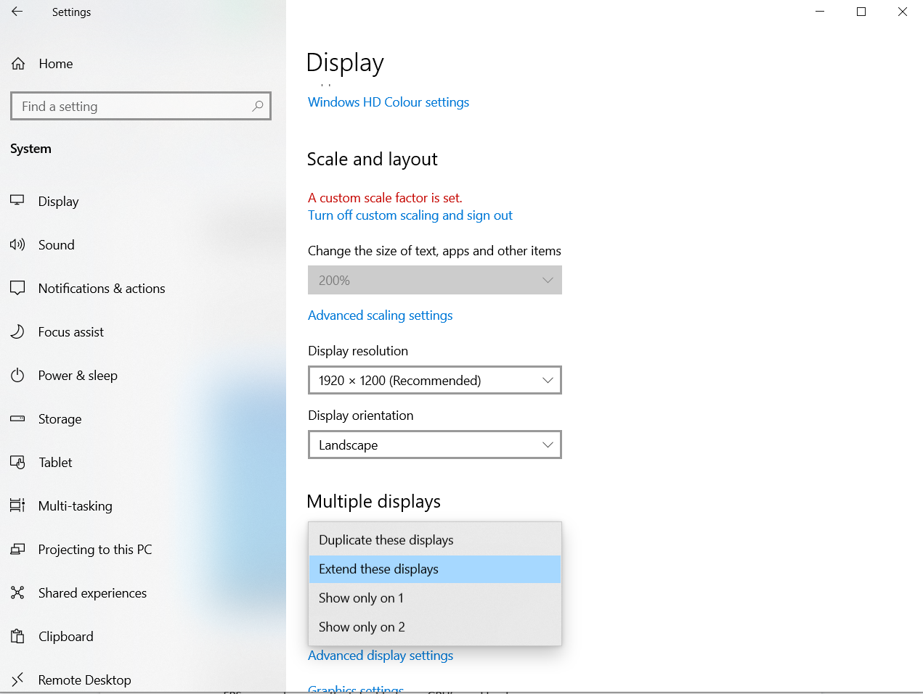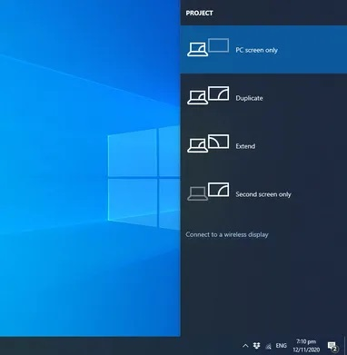

1. When you have both monitors connected, the **Windows desktop** will be displayed on **both** **screens**.
2. If you are not getting a signal on the **2nd monitor**, check the **connection and power** to the **2nd monitor** and check the **OSD** (on screen display) on the monitor or TV.
3. Press the **Windows** **Key** and **P** to bring up the configuration choice.
4. The most used option is **Extend**, which extends your display across 2 screens.
5. The next most used option is **Duplicate** which duplicates the display on both screens.
6. Alternatively, click on the **Settings** cog, then **System**, then **Display.**
7. With **Extend** you can choose **screen 1** as the gaming screen and **screen 2** for internet browsing, or you can extend the gaming display across both screens for a widescreen experience.

System

**P**

CONNECTING YOUR MONITOR

PAGE 5

* 1. **Dual Monitors**

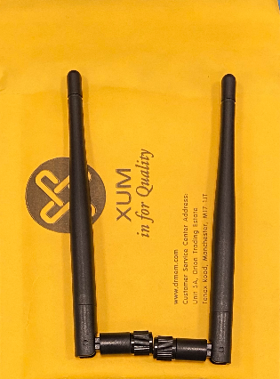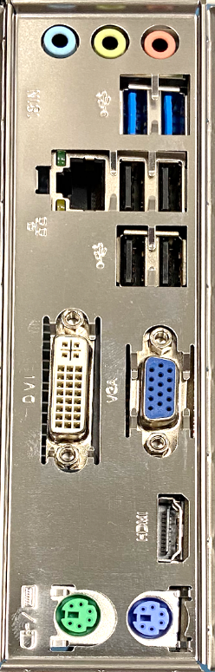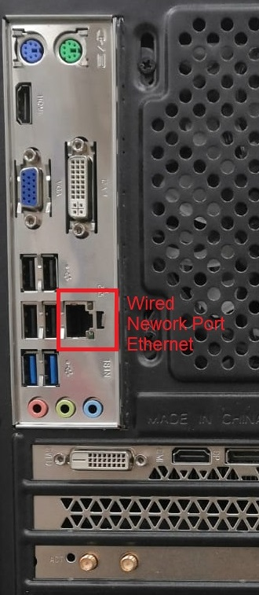

**Ethernet Port**

* Attach the **Wi-Fi Antennas** to the **gold** sockets at the rear of the PC as shown below.
* Or use the **Wired Ethernet** **port (RJ-45)** on the motherboard.
* For **online gaming**, wired is always best.
* Connect to a **home network** via **Wi-Fi** or **Ethernet** and you should be ready to start downloading and playing games!

NETWORK

PAGE 6

**4.1 Network**

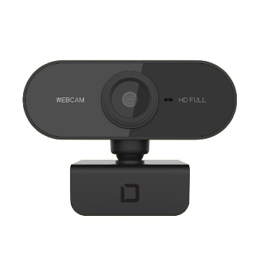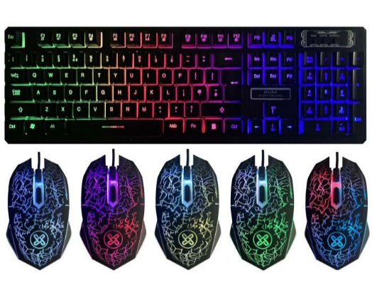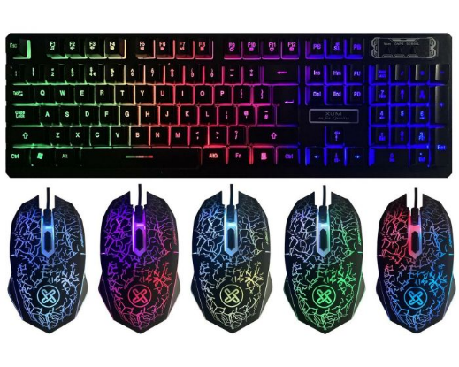

MOUSE AND KEYBOARD

* Plug in the **mouse and keyboard** into the black **USB 2** ports.
* Reserve the **blue USB 3** ports for high-speed devices, such as external hard drives or webcams.
* You can also control the case lighting with the included **remote control**, or (on some cases) the **LED button** on top of the case.

**4.2 Mouse & Keyboard**

PAGE 7

USB 2 Ports

USB 3 Ports

PAGE 8

**4.3 Useful Key Bindings**

Website

**FN**

**F9**

Adjustable DPI / Mouse Sensitivity

**SL**

LED’s ON/OFF

**F10**

**F11**

**F12**

Mail

Folder

Help

**FN**

**FN**

**FN**

Play / Pause

Next Track

Prev Track

Vol Down

Vol Up

Stop

Mute

Player

**FN**

**F3**

**FN**

**F2**

**FN**

**F1**

**FN**

**F4**

**FN**

**F5**

**FN**

**F6**

**F7**

**FN**

**FN**

**F8**

Useful Key Bindings

MOUSE AND KEYBOARD

HEADPHONES & SPEAKERS

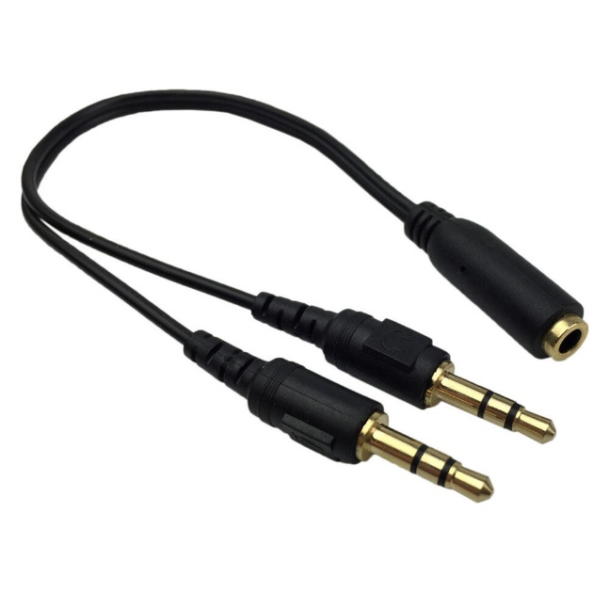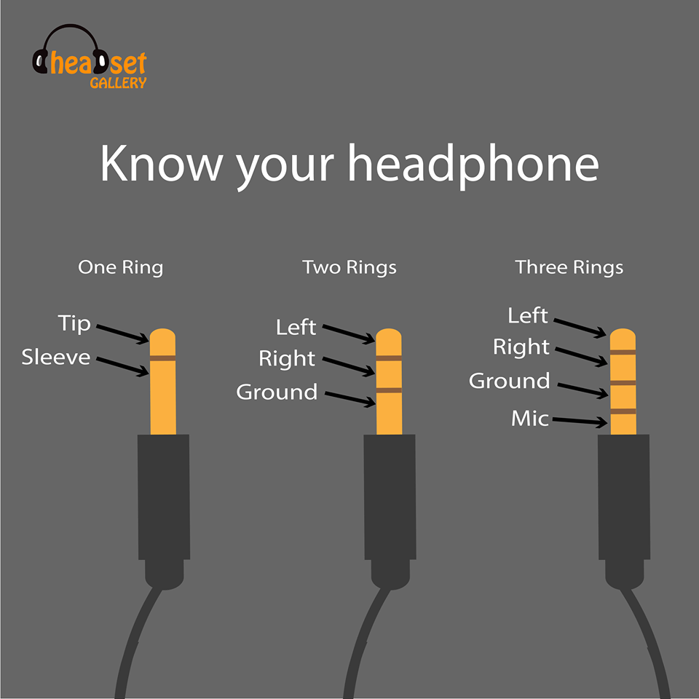

* **Pink** is for **Microphone** | **Blue** is **Line in** | **Green** is **Speakers / Headphones**.
* If you are using a **gaming headset** with a single audio jack you will need an **audio splitter**.
* If you choose to use **Bluetooth**, you will need a USB Bluetooth adapter as this machine **does not** have built-in Bluetooth.
* **Gaming headsets** with a single audio jack require an audio splitter. **Two rings** are for **stereo**. **Three rings** are for **stereo** and a **microphone**.
* **USB headphones** often have **virtual 3D sound capabilities** and can be better for gaming.

**5.1 Headphones & Speakers**

PAGE 9

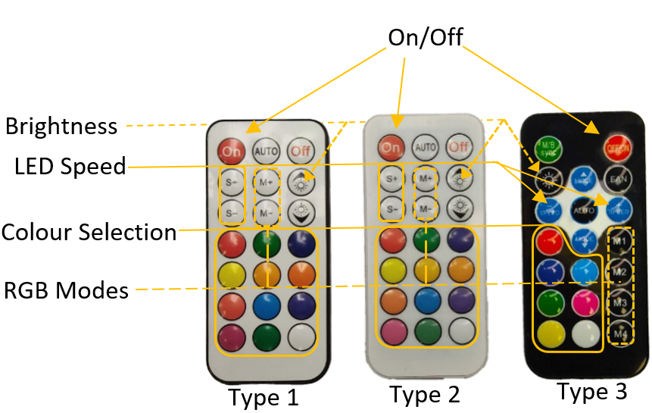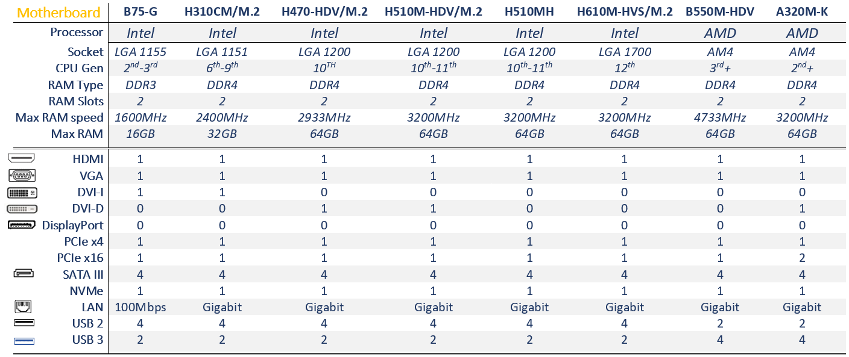

**6.2 Remote Control**

**6.1 Motherboard Specifications**

Remote Control

MOTHERBOARD SPECIFICATIONS

PAGE 10

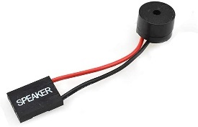

**BIOS Beeper Guide**

PAGE 11

* **1 Long** Beep
  + No Issues
* **1 Long, 2 Short** Beeps
  + **Failure** in **video system** – E.g., **new hardware**, a **malfunctioning Fan**, a **CD / Disk**, or **power supply**.
* **1 Long, 3 Short** Beeps
  + **RAM / Memory failure**
* **1 Long, 8 Short** Beeps
  + Video adapter missing / defective.
* **1 Short** Beep
  + DRAM refresh failure
* **10 Short** Beeps
  + CMOS shutdown Read/Write error
* **11 Short** Beeps
  + Cache Memory error

**7.1 BIOS Beeper Guide**

PAGE 11

* **2 Short** Beeps
  + Parity circuit failure
* **3 Short** Beeps
  + Base 64K RAM failure
* **4 Short** Beeps
  + System timer failure
* **5 Short** Beeps
  + **Process failure** - The system **CPU** has failed
* **6 Short** Beeps
  + **Keyboard not present**
* **7 Short** Beeps
  + **Fault in the CPU or motherboard**
* **8 Short** Beeps
  + Read / Write Test Failure E.g., **new hardware**, a **malfunctioning Fan**, a **CD / Disk**, or **power supply**.
* **9 Short** Beeps
  + ROM BIOS checksum failure

This **small device** attaches to the **motherboard** and makes various beeping sounds based on any **issues** with the computer. Here is a **breakdown** of every different **beep composition** and what it means.

**How to Return a PC**

**Returning For a Refund?**

You can return a PC for a full refund if we have been notified within 30 days of the goods being received that you want to cancel the order. You have another 14 days to return the goods once we have been notified **(See Warranty first).**

**Returning For a Repair/Replacement?**

You can return a PC for a repair/replacement if we have been notified within 365 days of the goods being received **(See Warranty first).**

**£**

**+44 161 877 0030**

**support@drmem.com**

PAGE 12

***See full warranty policy on Page 14***

**8.1 Contact us**

1

2

1

**Return Checklist**

**Back-up** your HDD and/or SSD data before returning. We **are not** responsible for any **loss of data** that may occur during repair or replacement.

**Only** return the **PC itself.** **Do not** include any cables or accessories.

Remove the user password from your PC or contact us with user details before returning.

**Packaging the PC**

You will need to pack your XUM PC safely and securely before shipping it back to us. We **are not** responsible for anything damaged in transit. It is best to return the item as originally packaged. If this is not possible follow the instructions (right):

**Double Box the PC**

Protect your PC so not to get damaged in transit by packing it securely.

1. Place the PC in a cardboard box **(Box 1),** filling any empty space with packing material such as bubble wrap to make sure it doesn't move around, then seal **Box 1** with packing tape.
2. Place **Box 1** into a second outer box (**Box 2)**, also filling any empty space with packing material such as bubble wrap to make sure it doesn't move around, then seal the box with packing tape.
3. **Contact Us** to arrange a **collection** time and date that suits you.

A courier will collect and label the parcel between 9am – 5pm, Weekdays (excluding bank holidays).

**8.2 Returns Checklist**

PAGE 13

**How to Return a PC**

**8.3 Warranty**

**Warranty**

**What is not covered under Warranty?**

* This Guarantee does not cover

your data, or any peripherals that are not manufactured by XUM and were not originally included.

* Any damage sustained to the PC

in transit back to us (see page 13).

**When is Warranty Void?**

* The warranty period has expired
* Failure or damage due to misuse such as, water damage, physical damage.
* Altering the product unless expressly permitted in writing by us.
* The following components have been replaced by a third party: HDD, SSD, RAM, CPU, GPU, MOTHERBOARD, CASE, PSU
* The product has been taken to a third-party computer repair shop.
* Motherboard,PSU, or CPU failure due to overclocking.

XUM guarantees that this product is free from defects in **materials** and **workmanship** that result in product failure during normal usage in accordance with the terms set out on this page and will, for a period of 1 year from the date of original purchase.

We guarantee repair or replacement of any component that is part of this product, free of charge, where it is faulty due to defective **materials** or **workmanship**. Replacements will be with new or, refurbished components.

If a repair/replacement is not possible we reserve the right to offer an alternative of equal or greater value (at the customers’ expense) or a partial refund proportional to the cost of the part.

Warranty is non transferrable and applies to the original purchaser only. Proof of purchase is required with all potential warranty claims.

PAGE 14

Support Page

www.support.drmem.com

* You should now be **good to go!**
* Windows is **pre-activated** for you.
* If you run into an issue, then please see our online guides for troubleshooting tips (Scan **QR Code Above**).
* You can also get in contact with us via email or phone from **Monday – Friday (Excluding Bank Holidays)**.

PAGE 15

**support@drmem.com**

**www.drmem.com**

**+44 161 877 0030**

PAGE 12

www.support.drmem.com

Follow us on Social Media

*****

PAGE 16

@xum-enterprise-ltd

@Dr_Memory_UK

**Twitter**

@xum_enterprise

**Instagram**

**LinkedIn**

@DrMemoryUK

**Facebook**

PAGE 12

PAGE 12

